

CERTIFICATE OF EMPLOYMENT

TO WHOM IT MAY CONCERN:
`

This is to certify that Krisha Faith Pabillore is employed at PURx Pharmacy as Purchasing Staff Cagayan de Oro base.

This certification is being issued upon the request of Ms. Pabillore for school requirement and for whatever legal purpose it may serve.

Issued this 26th day of June 2026 at Poblacion, Catarman, Camiguin.

For further inquiries, verification, or clarification regarding this certification, please contact us through the following:

Email: griczpearlpleia@gmail.com
Contact Number: 0961-761-5882

Sincerely,

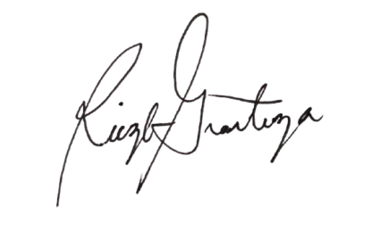

RICZL PEARL PLEIA GRANTUZA
Owner PURx Pharmacy

